Social Theory of a Sustainable,

Collaborative Learning Society

Hans de Bruin

February 14, 2020

Status: rough draft

Contents

1 Introduction 1

2 Social Theory Process 3

2.1 Implementation Process 4

2.2 Reflection Process 6

2.3 Democratic and Strategic Process 6

3 Facilitating Change 7

4 Applying the Social Theory in Organizations 7

5 Program Management 8

6 Beyond Local Initiatives 9

7 Reflecting on the Social Theory 10

Terminology:

* Cultural identity, nu ethische uitgangspunten
* Society, alternative community
* Assessment framework, including guiding principles, considerations, and rights and obligations.
* Implementation process, nu uitvoeringsproces

To do:

* Ethische aspecten moeten nog in het verhaal worden verweeft.
* Sociale theorie illustreren met voorbeelden.

# Introduction

Preparatory reading: Foundation, in particular Systems Thinking, Expertise Management Methodology

The social theory of a sustainable, collaborative learning society, or Social Theory (ST) for short, provides a framework for realizing sustainable changes that are widely supported in society. The term theory might come across as a collection of ideas not rooted in reality devised by a researcher stationed in an ivory tower, but as Kurt Lewin famously stated: there is nothing as practical as a good theory*.* ST is grounded in the foundational framework (*link*), in particular the Expertise Management Methodology (EMM). EMM provides a process for collaboratively understanding complex situations in which stakeholder’s worldviews may differ, even radically.

Principle: The parts must be understood for understanding the whole, but the parts cannot be understood without the context given by the whole, which is made up by its parts.

The keywords are understanding and meaning. Before anything else, the goal is to find out collaboratively what is going in a situation and what can be done to improve it as perceived by stakeholders. At this stage, the goal is not to find a solution per se, but understanding each other’s position might already paves the way to an accommodation of worldviews that can be implemented.

Principle: the keyword is understanding. Research approach must be “for you, and with you”, instead of “for you, but not with you”.

With EMM, the insights and expertise of the stakeholders is captured in such a way that it can readily be extended. This allows to build Bodies of Knowledge and Skills (BOKS) systematically that serve as a base for finding improvements in situations that are arguably desirable and culturally feasible. This all amounts to a collaborative learning society. EMM itself is founded on a strong basis, including systems thinking, ethics of care, and Luhmann’s social theory.

EMM, however, cannot guarantee that accommodation of worldviews will happen, nor can it ensure that changes will last. ST comes to rescue here. The key idea is to steer on cultural identity: who are we, and what do we do? EMM is instrumental in finding mutual understanding, but it takes a process of reflection to find shared meaning based on our understandings. The shared meaning thus established steers a governance process leading to an assessment framework to frame solution directions. Of course, not everyone will agree with proposed solutions – e.g., the not in my backyard syndrome is famous for that– but whatever decision taken, the assessment framework that guides decision making is grounded in mutual understanding and shared meaning.

Principle: a constructive dialog can take place on the basis of first and second order boundary judgments.

Essentially, the ST induces a transition in society from focusing on verification – are we doing things right? – to validation – are we doing the right things collectively? So, the transition is not primarily about addressing wicked problems like climate change or social injustice, but it is really a kind of meta-transition changing our attitudes and developing our skills to cope with wicked problems and to use the same wicked problems as a vehicle to make that transition. This is not an easy transition because it has to be done with all involved in a problematic situation and it presupposes trusting each other. The latter cannot be enforced, but the engagement of stakeholders in EMM processes of mutual understanding makes trust possible. But as will become clear, every step taken in the transition process is already an improvement because of the undercurrent of mutual understanding and shared meaning.

Principle: the relationship between things, including humans, is what matters. Something or someone cannot stand or be taken on its own.

# Social Theory Process

Preparatory reading: Introduction, Systems Thinking, Second-Order Cybernetics, Deliberative Democracy

Continue reading: Applying the Social Theory in Organizations

The Social Theory (ST) process is geared towards discovering a shared meaning on the basis of mutual understandings. It is a circular, never ending process that continuously reassesses lessons learned from concrete activities. So, shared meaning is not carved in stone. It is part of our tradition, which evolves as result of changing circumstances that requires to reconsider our relation with the outside world, including advancements in science and technology.

Principle: tradition is overarching.

Learning takes place on at least two levels. The first learning level is about understanding the ins and outs of the problematic situation at hand. The second learning level is to understand the ST process itself and to acquire the skills to be engaged in the ST process. (And yet at another level, the originators of EMM and ST learn from these learnings.)

The circular ST process is shown below. It is comprised of four main processes that transform a given input to some output. This corresponds to the classical conception of systems thinking in which a system performs a purposeful input-output transformation (see …). The overarching, circular ST process, however, adheres to the second-order system concept of self-producing in order to sustain itself in changing circumstances (see …). The reason of being (*raison d’être*) is our cultural identity expressed as “what we are” and observed in “what we do”.

Principle: We are living in a reflexive domain in which cause and effect coincide.

Principle: a system comprised of a number of interacting feedback loops is a complex system whose behavior can surprise us.

Principle: we have to become what we are not, and yet remain the same.

Principle: the constant factor in life is movement.

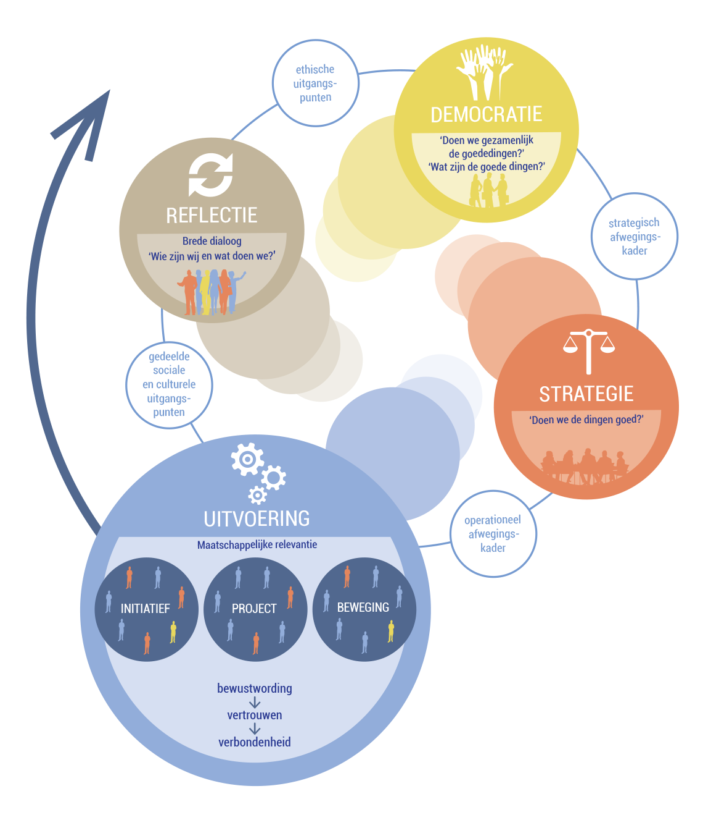

## Implementation Process

The implementation process is a catch-all term for all kind of activities that are going on in society, including projects, movements and grass-root initiatives. They all have one thing in common, and that is being of relevance for society. This implies that all stakeholders should be involved, including citizens, government, organizations, and companies. These are all members of society who can voice their concerns. However, there are parties, such as vulnerable individuals, oppressed groups, and nature, that can hardly express themselves or not at all, and their concerns should be taken into consideration as well. To this end, the implementation processes are taken place within the confines of the assessment framework.

The assessment framework is comprised of guiding principles, considerations, and rights and obligations. They ensure an equal playing field for all involved by providing the rules of engagement. As such, the assessment framework reflects our cultural identity by expressing in a very practical way what we value and how we ought to behave in generally accepted ways. (On a meta-level, playing by the rules should be part of our cultural identity. And generally speaking, most people stick to this principle, although some people have only an eye on their own concerns. By including the “play by the rules” principle in the assessment framework, the majority has the power to disqualify such self-interest, with the side note that power abuse by those in real power is hard to rule out.)

*Acceptabel niveau van leven in relatie tot sociale en fysieke omgeving.*

*Een paar concrete voorbeelden hier:*

* The well-being of a person in relation with his or hers social and physical environment is central.
* A common interest supersedes an individual interest.
* Play by the rules!

The assessment framework is the outcome of a democratic and strategic process. These two processes are influenced by our experiences obtained from implementation processes and reflections on them. So, we act within the confines of the assessment framework, but the framework is subject to change due to a critical assessment of the framework itself. To put it differently, the assessment framework is continuously validated and adapted accordingly by asking are we still doing the right things collectively.

An implementation processes can be shaped in such a way that it befits the situation at hand, but preferable an EMM process should be deployed. EMM is a methodology (see …), and as such, it is open to incorporate specific methods and techniques. The important thing to realize is that EMM is about gaining mutual understanding of a problematic situation. This raises awareness amongst those involved. And by really understanding each other’s position, it makes trust possible, and hopefully, it eventually leads to connectedness. Trust and connectedness are not abstract, rational concepts. On the contrary, they can only be lived through on a personal level in the context of an implementation process. Trust and connectedness must be experienced to grow.

Principle: you need someone else to point out your blind spots to you.

Principle: the keyword is understanding. Research approach must be “for you, and with you”, instead of “for you, but not with you”.

The execution of an implementation process takes place within the context of the assessment framework. This provides the setting for accommodation of worldviews (see SSM). Nevertheless, the assessment framework may fell short to be decisive in all cases. However, this should be seen an asset rather than a deficiency. That is to say, there should be room for disagreement in order, among other things, to voice differences in opinion and to encourage innovation, although this effectively may stall an implementation process. In that case, the ST process provides the means to reassess the assessment framework.

Principle: the relationship between things, including humans, is what matters. Something or someone cannot stand or be taken on its own.

Principle: people differ in worldviews, but nevertheless they typically adhere to aspects of multiple worldviews, which provides room for accommodation.

An implementation process should preferably yield a triple stroke:

* making progress in a problematic situation in the sense that a mutual understanding is obtained, and if possible, ways are found to take action;
* acquiring new skills by all involved, in particular systems thinking as practiced in EMM and ST;
* learning lessons from the experiences gained in the implementation process about cultural identity.

This is quite some list. Initially, skilled facilitators of change can help managing this, in essence, group learning process. Facilitators of change are supposed to be independent, and therefore can be trusted by all stakeholders. The government could fulfill the role of facilitator of change. After all, the government serves in the interest of society. Unfortunately, this point has not been reached yet because the government is looked upon with suspicion, partly caused by potentially conflicting tasks such as stimulating new initiatives and policy enforcement, and partly because of the inherent misbalance in power between the government and a civilian. As long as the government is seen as an outside party of society rather than an insider having distinct roles, rights and obligations, the government is not in a position to facilitate implementation processes. The government is a powerful institution, but it should not abuse its powers (or is perceived as doing so), and play by the rules set out in the assessment framework to evolve into a well-respected and trustworthy member of society. Implementation processes provide opportunities to do so.

Minor Fit for the Future als voorbeeld gebruiken.

## Reflection Process

The reflection process serves the purpose of transforming experiences and insights obtained from implementation processes to a vision of cultural identity. This is not a vision in an abstract sense, but contains elements that could be part of the assessment framework. However, these elements should be seen as unsolicited advice. The owners of the democratic and strategic processes carry the ultimate responsibility for the content of the assessment framework. Because the advice is grounded in mutual understanding as a result of implementation processes in which the government took part, the government is actually not really in the position to ignore the advice.

Principle: a constructive dialog can take place on the basis of first and second order boundary judgments.

It is important to stress that the government should not be the owner of the reflection process because if it is, the authority of the assessment framework would diminish. However, the reflection process can be organized on behalf of the government. Alternatively, if the government chooses not to be involved, the reflection process can be initiated by parties in a society. Whatever the case may be, the reflection process can best be seen as a form of deliberative democracy (see second ring: …) in which the voice of society as a whole is heard and taken seriously.

A deliberative democracy can take on many forms, including referendum and citizens council. One specific form is discussed here that befits the ST process. It is called the Council of Wisdom (CoW). In particular, the concepts of assessment framework and mutual understanding play a central role in a CoW. The CoW, as it name suggests, consist of wise people from the ranks of professionals, entrepreneurs, government, researchers, and experience experts. They have the desirable trait of having the willingness to see things broadly and across party lines. Their task is to transform mutual understanding into a well-founded vision on cultural identity expressed in terms of the assessment framework. Since the CoW has no monopoly on wisdom, the vision is open for discussion in all kind of forms, such as a broad dialog or internet consultation. Once this consultation round is over, the revised, widely supported vision is handed over to the government as an unsolicited advice.

CoW illustreren aan de hand van een voorbeeld.

## Democratic and Strategic Process

The democratic and strategic processes steer, control, and implement the assessment process. At the municipal level, the local council and municipal administration are responsible for these tasks. ST presupposes a democratic society, although this is not a strict requirement, because ST can also be applied in organizations that value the opinions of employees (see …). Most western democracies are representative (indirect) democracies based on the principle of elected officials representing a group of people.

The local council is responsible of representing people, establishing a framework to govern, and controlling that the municipal administration implement policies within the demarcations set out in the framework.

*Verder uitwerken:*

* *Rollen van overheid.*
* *Wat voegt het assessment framework toe aan het bestaande framework: expliciteren van culturele uitgangspunten, concrete afwegingen, etc.*
* *Overheid zit in een unieke positie, maar die komt met verantwoordelijkheden.*

# Facilitating Change

Preparatory reading: Social Theory Process

Continue reading: Applying the Social Theory in Organizations

The problems that we are facing today have a wicked nature. There are no easy solutions for climate adaptation and social injustice, to name a few. A wicked problem is often not well-understood and because of differences in worldviews, it is hard to find ways to make progress, let alone solving it. As discussed, EMM and ST are deployed to make progress in such cases. EMM provides a methodology comprised of a process (i.e., guided conversations and interpretation) and a modeling technique (i.e., EMont) to establish the ground for mutual understanding, whereas ST provides a circular process geared towards shared meaning. ST is not only about making progress in wicked problems, rather the aim is learning new skills with which wicked problems can be tackled. So, wicked problems should be regarded as opportunities to learn making progress collectively, which is by the way a wicked problem itself. Facilitators of Change (FoC) help to manage EMM and ST processes, but part of the ST process is acquiring, among others, EMM and ST skills by all involved in order to become FoCs as well, or at least to understand and appreciate the process.

FoC skills (v*erder uitwerken en aangeven waarom dit de juiste skills zijn*):

* Conceptual thinking
* Critical reflecting
* Connecting people

# Applying the Social Theory in Organizations

Preparatory reading: Social Theory Process

Continue reading: Program Management

ST was developed with wicked problems in mind affecting all members of society. This does not mean that society as a whole is ST’s only application area. It can also be applied in NGOs and businesses, although the terminology has to be adapted to suit this purpose.

Organizations, including NGOs and businesses, are not operating from democratic principles. Yet they do have one essential property in common with a democratic society. In order to sustain, they all have to adapt to changing circumstances. An organization has to be well aware of what is going on in the outside world in order to remain viable. And this is precisely what ST can offer. The reflection process can be put to good use to stay relevant by getting a critical, outsider’s view on the organization. The organization itself can organize the reflection process, but it must guarantee and value its independent role. In short, the organization empowers its hardest critics and it appreciates the naked truth they bring to the table. This borders on self-chastisement.

Organizations are typically organized in a top-down fashion steered by a board of directors and controlled by a supervisory board. Most organizations do value the opinions of employees, but a systematic approach to learning and improvement is the exception rather than the norm. Notable exceptions are organizations that implement trajectories centered around continuous improvement (PDCA, Lean, Six-Sigma, etc.). However, the focus is typically more on verification (doing things right) than on validation (doing the right things). The ST process focuses on validation to make an organization agile, but validation cannot be seen independently from verification.

Perhaps the most valuable asset of ST is the development of facilitator of change skills by employers and employees. ST provides the process to acquire the skills in practice. Moreover, the skills can be seen as a way of being, which in the context of ST is continuously adapting to changes in the outside world by means of mutual understanding and shared meaning. An organization having such a mindset is an organization that puts individual and group learning center stage, which amounts to a lifelong learning organization.

In conclusion, the ST process has much to offer to organizations, but as remarked before, the terminology has to be adapted, which can be done as follows:

* Implementation process → on-going daily process (performed by employees);
* Reflection process → advisory process (performed by independent experts);
* Democratic process → supervisory process (performed by supervisory board);
* Strategic process → steering process (performed by board of directors).

# Program Management

Preparatory reading: Social Theory Process

Continue reading: Beyond Local Initiatives

The ST process guides implementation processes in a particular direction within the context of the assessment framework. By putting the ST process in a different perspective, as shown below, it becomes clear that the ST process can be seen as program management. The ST process ensures that the direction is adapted continuously on the basis of new insights and changing circumstances. This constitutes a sustainable, collaborative learning society.

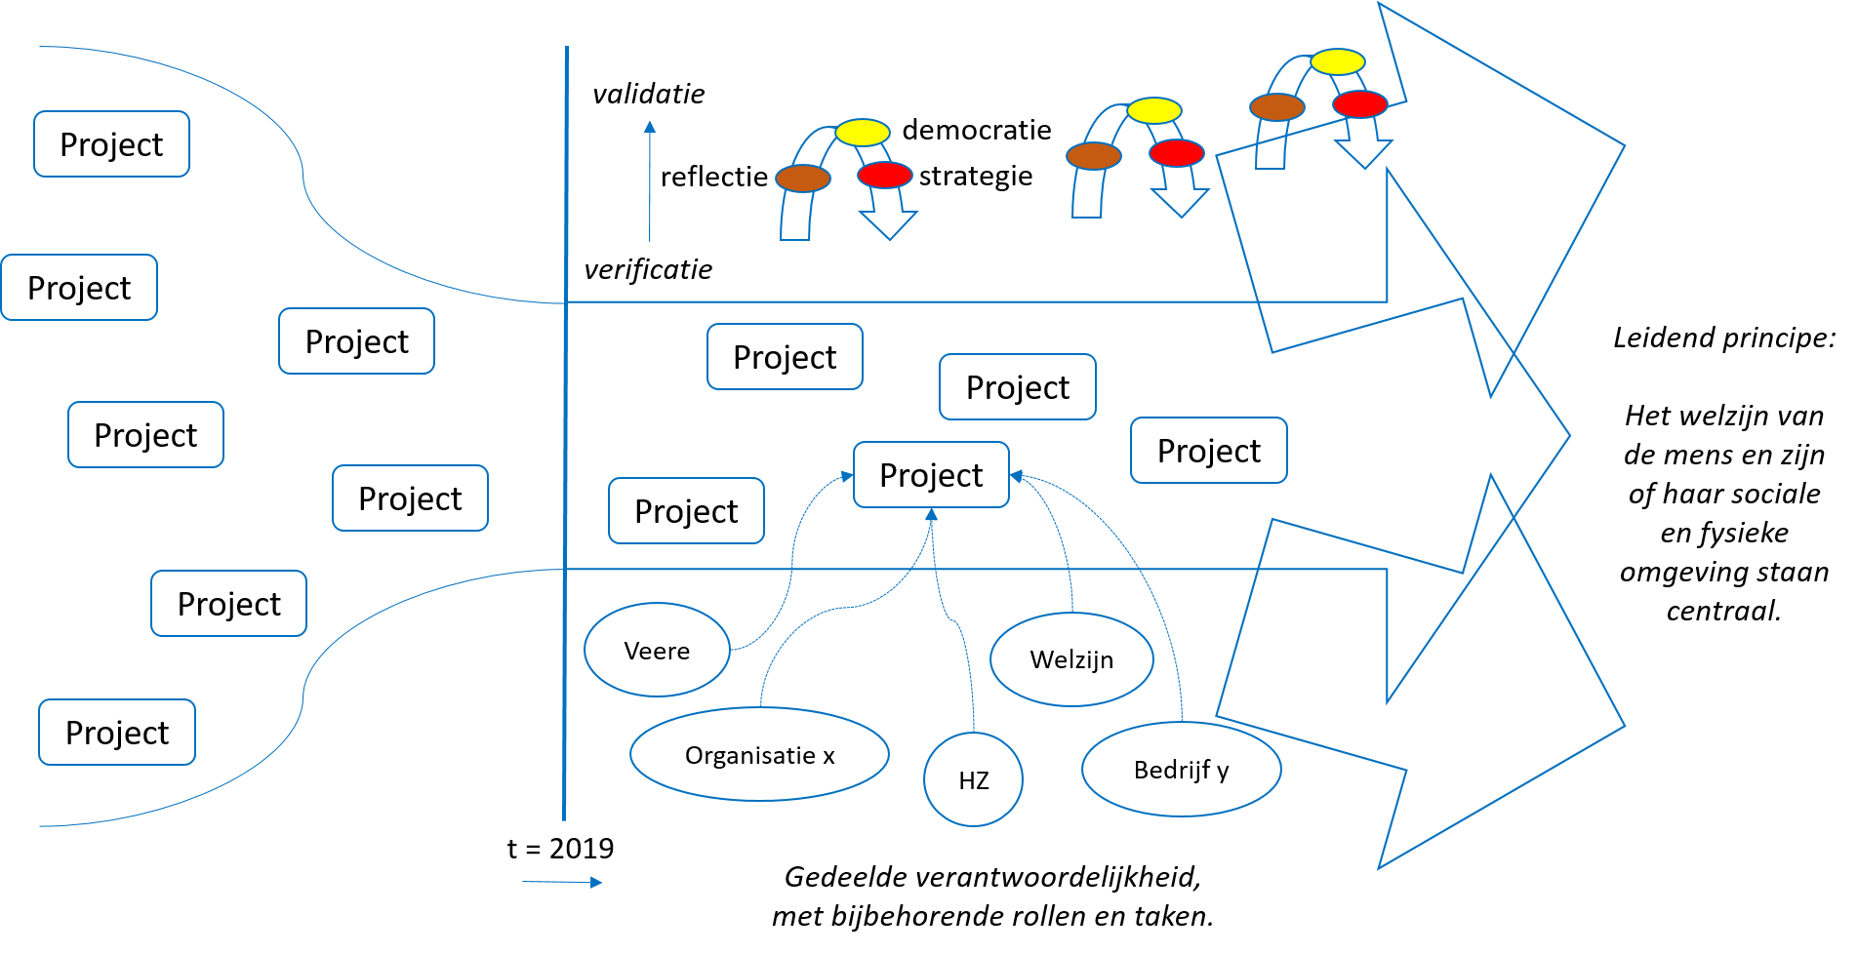

# Beyond Local Initiatives

Preparatory reading: Social Theory Process, Program Management

Continue reading: Reflecting on the Social Theory

ST presented so far is implicitly positioned in a local, municipal context. The maxim is: think globally, act locally. This expresses the idea that global change starts with local initiatives to give good examples of improvements to be implemented on a larger scale. This bears the question: it is possible to embed the ST process in another ST process so that in the end we do act globally? The answer is given in the diagram shown below. The basic idea is that a ST process is seen as the implementation process in a higher level ST process. In this way, the ST process is extended from a local level to regional and national levels, and if we dream on, even up to the global world.

Although the nested ST processes form a hierarchy, it does not mean that ST processes taken together have a strictly top-down or a bottom-up orientation. Just like a single ST process, the combined ST processes have circular processes at work at the same time. In this way, ideas and rules of engagement can flow freely upwards and downwards to set the right conditions for change at all levels.

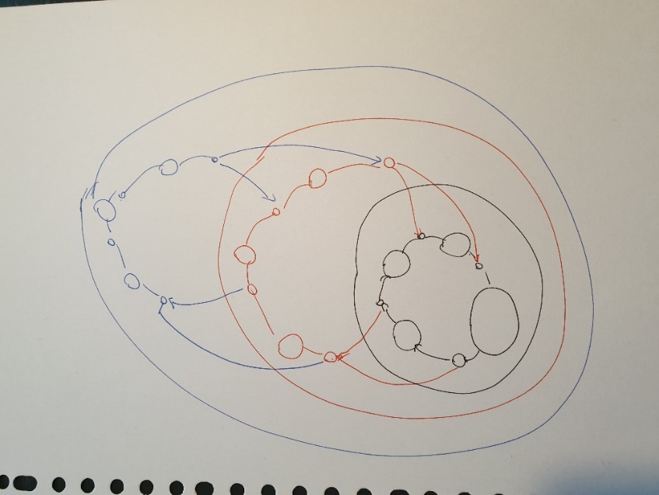

# Reflecting on the Social Theory

Preparatory reading: Social Theory Process, Facilitating Change, Program Management

Continue reading: this is it, we are done.

Dit is een eerste aanzet. Nog verder uitwerken.

In our experience, the ideas advanced by the social theory of a sustainable, collaborative leering society can be overwhelming. Therefore, the key notions of ST are summarized along with a discussion why they are crucial.

* Meta-transition: acquiring skills to tackle wicked problems.
* Assessment framework provides an explicit structure on which a society can be grounded. We are aware that a perfect society does not exist in the sense that disagreements and imbalances of power will always remain, but the least we can do is to create an equal playing field the best we can that is enforced by an assessment framework. And perhaps having such an equal playing field is the sign of a perfect society. The framework guides and stimulates activities. And by reflecting on the activities, the framework is adapted. It reflects our current status of what we are and what we do.
* Government has the power to steer transparently on shared meaning as expressed in assessment framework: arguably desirable and culturally feasible.
* The governments’ power stems from implementing desirable policies funded by taxes. However, it is a truly democratic process (a mixture of representative and deliberative democracy) because the society as whole determines how taxes are spent.